ORDER FORM

SCHOOL/CLUB _________________________________ ORDER NO: ______________

DELIVERY ADDRESS _______________________________________________________

ATTN: _____________________________ PH __________________

Email: ____________________________________________________
Quote Required: YES/NO

Code | Description | Price  (GST incl.) | Qty | Value
SP154521 | One Court System. 2x Bases, 2x Poles, 1 x Net. | $450.00
SP154522 | Two Court System. 3x Bases, 3x Poles, 2 x Net. | $700.00
SP154523 | Three Court System. 4x Bases, 4x Poles, 3 x Net. | $950.00
SP154524 | Four Court System. 5x Bases, 5x Poles, 4 x Net. | $1200.00
MA | Madison KiwiVolley Ball | $25.00
KVBS | KiwiVolley Booklet – Teaching the Skills | $2.00
KVBT | KiwiVolley Booklet – Teaching KiwiVolley | $2.00
KVBR | KiwiVolley Booklet – Rules and Refereeing | $2.00
KVBG | KiwiVolley Booklet – Grills (Game like drills) | $2.00

Normal freight charges apply.

Email order to om@volleyballnz.org.nz

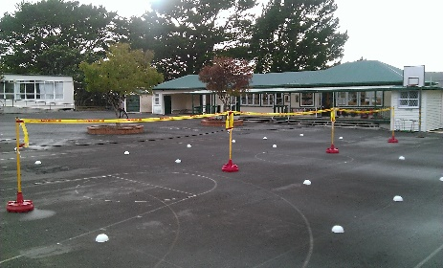
is the Official Ball of Volleyball New Zealand

Sportime ‘big red base’ courts systems. Can be used indoors and outdoors.
(Also suitable for volleyball, badminton and short tennis/padder tennis)

