Performance Programme Coach
Selection Application 2019-2021

Volleyball New Zealand (VNZ) has been working closely with Sport New Zealand and also consulting High Performance Sport New Zealand with our new Volleyball New Zealand Development and Performance Strategy.
The VNZ Athlete Development Pathways
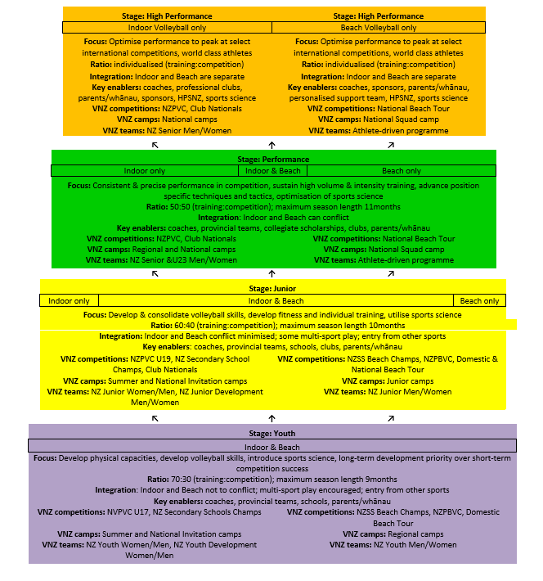

VNZ is now calling for applications for Senior Women’s and U23 Women’s Age Group Coaching positions in indoor volleyball for the 2019 through to 2021 seasons with the pinnacle event, Asian Champs in 2021.

Applications are now open for the positions detailed on the Application Form below. Where possible we have detailed the expectations relating to national training camps as well as the potential tours. Currently these roles are for the 2 year cycle period. Further consideration will be given to an extension to 2 year cycle periods but at this stage we will retain the status quo.

Please indicate clearly if you are interested in more than one position with your order of preference.

VNZ has a number of expectations for those appointed to these positions as the roles are important for VNZ and are hugely influential in terms of the development of our game. VNZ has a Game Development Manager that will be the key link for Development and Performance of volleyball in NZ.

VNZ is looking for coaches who will:
- Support and implement the VNZ Development and Performance Strategy.
- Respect and value both beach and indoor programmes
- Have a continuous learning commitment
- Adhere to VNZ coaching principles and values
- Work closely with VNZ and those in roles supporting Performance Volleyball
- Connect with VNZ National Office re team logistics as required
- Work collegially with other NZ Coaches
- Attend and manage where applicable Age Group Trials, Performance Age Group Camp, National Beach Camp and any other relevant events
- Utilise and adopt relevant international good practice that develops coaches and athletes including athlete testing, communications, technical skill development
- Prepare and present a season plan from selection to event to the part time VNZ Development and Performance Lead including training camps, budgets etc
- Must provide individual feedback (technical, tactical and behavioural) to athletes
- Communicate in a timely manner with VNZ

VNZ also has the following expectations of team management:
- Support the VNZ Development and Performance Strategy
- Must travel to and from events with the team
- Must (with the manager) provide regular tour/event updates to VNZ National office for use on social media
- Follow VNZ’s instructions on Facebook / Instagram groups for communication
- Acknowledge and support VNZ sponsors and funders – e.g. apparel supplier, travel provider

Coach Application Form
Please complete electronically.
Name
Email
Mobile
Home phone
Referee 1 Name
Referee 1 Mobile
Referee 2 Name
Referee 2 Mobile

Preference | Programme | Year | Athlete Year Group
 | INDOOR
 | Senior Women | 2019-21
 | U23 Women | 2019-21

Applicants should provide a letter in support of their application (3-pages maximum) that outlines their experience with coaching, the level of the teams or athletes currently coached and over the last five years, what successes* they have experienced over that time, their personal coaching philosophy and why they want to be part of the VNZ Performance Programme.

*VNZ recognises that success is not limited to competition outcomes and applicants are encouraged to describe athlete development outcomes and a range of ways they may have added value to the long term development of athletes; in addition to including comment on other areas such as leadership and communication.

The above expectations will be used as part of the selection criteria.

Email applications to: om@volleyballnz.org.nz by 26th September 2019.
Interviews to be held where possible 2nd to 5th October 2019 in Auckland (Club Champs)
For further information or questions please contact VNZ Chief Executive, Toni-Maree Carnie ce@volleyballnz.org.nz

