WORKPLACE GUIDELINES FOR THE COVID PROTECTION FRAMEWORK

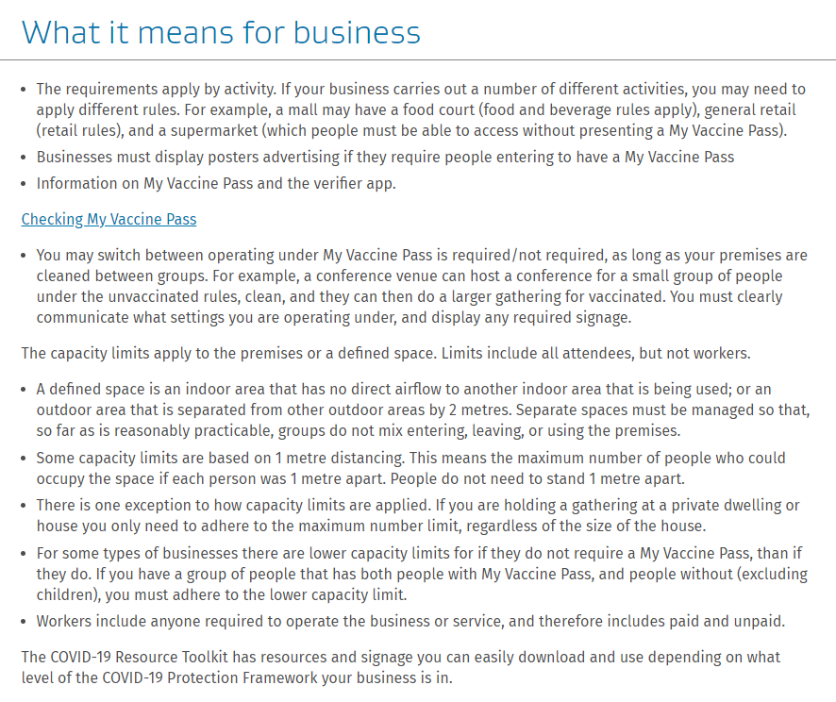

Workplace vaccination obligations
Employers have a health and safety duty, as far as reasonably practicable, to reduce the risk of a hazard occurring in the workplace. Therefore, employers must consider what control measures can be implemented to reduce the likelihood of the spread of infectious diseases in the workplace (eg COVID-19, Influenza, Hepatitis). This may include implementing an immunisation program encouraging, or in some circumstance requiring, employees to get vaccinated.

Risk assessments and meeting your obligations
Conduct a risk assessment in consultation with your workers to identify whether there is a risk of infection in the workplace and the likelihood of it occurring. Consider your business’ operations and industry, public health advice and if there are legislative or regulatory guidance on control measures.
Volleyball itself does not have legislative requirements but as a community facing activity and one held in facilities that may require vaccination, these requirements will need to be enforced.

https://employsure.co.nz/wp-content/uploads/2021/03/1.-FACTSHEET_NZ_Vaccinations-in-the-workplace_Hub-version.pdf

Notice period
New legislation means employers must provide a minimum four-week paid notice period for employees who have their employment terminated because they are not vaccinated, and their work requires it. If the notice period in the employee’s employment agreement is longer than four weeks, they will be entitled to this instead.
The notice period must be paid, including in most circumstances where the employee may be unable to work. The entitlement applies to both employees who are covered by a public health order mandating vaccination in a specific field and employees whose employer has determined the employee must be vaccinated to carry out their work.
It is important to take into consideration that the legislation also requires an employer to cancel the termination and allow the employee to come back to work if they get vaccinated during their notice period, except for in very limited circumstances.
Please contact the Advice Team on 0800 675 697 if you have specific queries on notice periods and your obligations.

Cost of vaccination and paid time off to get vaccinated
If the vaccination is required or mandated for your employees, you must pay the cost (if any). The Government has confirmed the COVID-19 vaccine is free of charge. A recent law change means you are also legally required to provide reasonable paid time off for all employees to get vaccinated.

https://employsure.co.nz/blog/coronavirus-faqs-and-resource-hub-for-employers/

